Academic Vocabulary

🎓 What is Academic Vocabulary
# Source: AI Source: Provided by: [Data Path: Persons Table -> ID Column: 1, Name_En Column: Motasem Essam] -> From: [Chatgpt (GPT-4-turbo)] on [7/30/2025]
Academic vocabulary refers to the words commonly used in educational, scholarly, and formal settings. These words are often more abstract, precise, and subject-specific than everyday language, and are essential for understanding textbooks, lectures, exams, and academic writing.

✅ Key Features:
# Source: AI Source: Provided by: [Data Path: Persons Table -> ID Column: 1, Name_En Column: Motasem Essam] -> From: [Chatgpt (GPT-4-turbo)] on [7/30/2025]
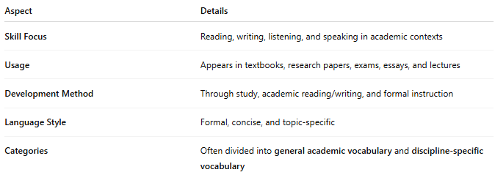
Aspect | Details
Skill Focus | Reading, writing, listening, and speaking in academic contexts
Usage | Appears in textbooks, research papers, exams, essays, and lectures
Development Method | Through study, academic reading/writing, and formal instruction
Language Style | Formal, concise, and topic-specific
Categories | Often divided into general academic vocabulary and discipline-specific vocabulary

🧠 Examples:
# Source: AI Source: Provided by: [Data Path: Persons Table -> ID Column: 1, Name_En Column: Motasem Essam] -> From: [Chatgpt (GPT-4-turbo)] on [7/30/2025]
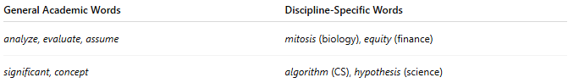
General Academic Words | Discipline-Specific Words
analyze, evaluate, assume | mitosis (biology), equity (finance)
significant, concept | algorithm (CS), hypothesis (science)

👤 Who Uses It?
# Source: AI Source: Provided by: [Data Path: Persons Table -> ID Column: 1, Name_En Column: Motasem Essam] -> From: [Chatgpt (GPT-4-turbo)] on [7/30/2025]
- Students (secondary, tertiary, graduate)
- Teachers and Professors
- Researchers and Academics
- Test-takers (e.g., IELTS, TOEFL, GRE)
- Writers in scholarly publications

📌 Related Vocabulary Types:
# Source: AI Source: Provided by: [Data Path: Persons Table -> ID Column: 1, Name_En Column: Motasem Essam] -> From: [Chatgpt (GPT-4-turbo)] on [7/30/2025]
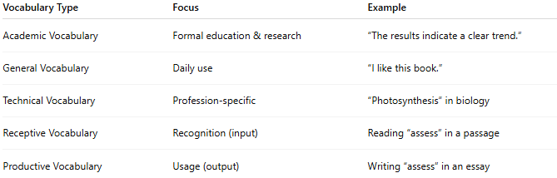
Vocabulary Type | Focus | Example
Academic Vocabulary | Formal education & research | “The results indicate a clear trend.”
General Vocabulary | Daily use | “I like this book.”
Technical Vocabulary | Profession-specific | “Photosynthesis” in biology
Receptive Vocabulary | Recognition (input) | Reading “assess” in a passage
Productive Vocabulary | Usage (output) | Writing “assess” in an essay

